**PROJECT PROPOSAL**

**IIT271-2**

**PAYROLL MANAGEMENT SYSTEM FOR TEA ESTATE.**

**Group No: 07**

|  |  |  |
| --- | --- | --- |
| **Group members:** |  |  |
| L.G.CHATHURUANGA |  | UWU/IIT/15/008 |
| H.P.M.M.HEWASUNDARA |  | UWU/IIT/15/020 |
| M.G.N.D.MORAWALIYADDA |  | UWU/IIT/15/034 |
| M.S.C.SANDEEPANI |  | UWU/IIT/15/045 |
| W.M.T.C.WIJERATHNAYAKE |  | UWU/IIT/15/058 |

# Supervisor Details:

Dr. Amal Rajapakse

Senior Lecturer

Department of Computer Science &; Technology

Uva Wellassa University

**Department Of Computer Science and Technology**

|  |  |
| --- | --- |
| c | Pub Management |
|  | Restaurant Management |
|  | Fixed assets management |
|  | Event & Merchandising Management |
|  | Customer Management |

**Uva wellassa University**

**August 2017**

**Introduction**

**Title** Payroll Management System for Tea Estate.

## Project Background

* The tea Estate Wewassa situated in Passara belongs to the Badulla district. Due to the improvement in the tea industry as well as with the urbanization, the factory has a considerably large customer base. The tea factory and the tea estate are situated in separate locations. Currently, the tea estate is running a manual file based system to carry out their daily Human Resources (HR) related tasks and the management is interested in leaving the old file-based system and moving to develop a computerized system.
* The main approach of the system is to provide salary details to financial Department. Also this project is going to cover up all the things from salary details, attendance details and leaves etc. which are currently done manually. In order to have a more efficient and easy to use system that is running smoothly, protect the important data for future use it is essential to develop a fully computerized system for handling the above tasks. For this purpose we are planning to make the system simple and easy to handle one by using a relational database. The reliability and the security of the system will be made available by providing a user name and password for the users of the system. State-of-the-art database and the technologies will be used to improve the efficiency, speed and high performance and necessary techniques will be used to secure the system by backing up data. Through this way, it is expected to fulfil the system tasks by overcoming the deficiencies and other shortcomings of the manual system.

**1.2 Main Objective**

The main objective of the planned system will be to maintain a fully computerized system with improved security, efficiency and reliability so that the factory can manage their daily tasks easily. Also, it is expected to use the new system to maintain the employee records including their attendance and wages among other.

In addition that,

-The facilitate controlling personal information of the tea state.

-To provide interactive attractive user interface.

-To provide salary details to main branch.

-To get an experience through this project.

**2**. **Project Description**

**2.1 Functional Requirements.**

# • Employee Information Module

* Login to the system
* Enter details for employee
* Update Employee Information
* Delete Information
* Edit Information
* Getting Attendance Performance Report

# • Payroll Module

* Login to the system
* View salary details
* Calculate leaves
* View Salary List
* Print Documentations
* Payment Calculation

## 2.2 Non-Functional Requirements.

* **User friendly-** To facilitate controlling information of the tea state and provide attractive interface to user.

* **Performance-** Facilitate the user to handle the system easily.

* **Security-**Facilitate the security of information through the passwords.

* **Usability**-The system is designed for user friendly environment, so that managers and workers can perform their tasks easily and effectively.

* **Efficiency**-When the payroll management system will be implemented, the managers can handle their information and salary calculation within less time consuming.

# .User Levels

* Manager-Admin user.
* Clerk –Normal user

**User Roles**

**Manager:-**

Login to the system

Control the user Accounts (Create, Edit, Delete)

View Salary List

Payment Calculation

Update Employee Information

Delete Information

Edit Information

View Attendance Performance Reports

Print Documentations

Payment Calculation

**Clerk:-**

Login to the system

View salary details

Calculate leaves

Print Documentations

Payment Calculation

Enter details for employee

Update Employee Information

Delete Information

Edit Information

View Attendance Performance Reports

**3. Methodology**

# RAD Model

We are planning to use the Rapid application development Model (RAD) as our system methodology. Because we can change the requirement rapidly. And enables to develop the system within short time period (Eg: 60 -90 days).

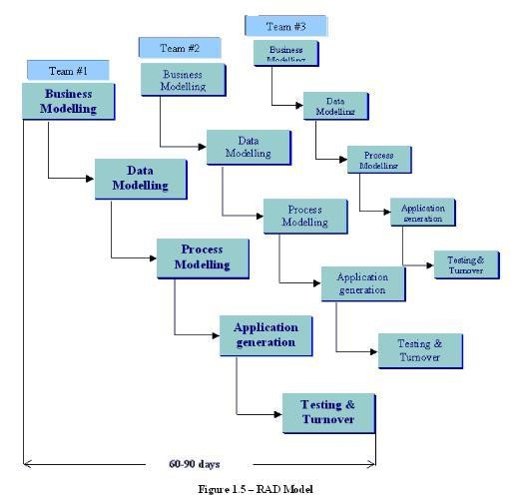

**Resources**

# • Software Requirements

* NetBeans IDE 7.4
* MS Word 2010
* Ganttpro to draw Gantt chart
* Photoshop CS5✓ .NET Framework 4.5
* MS SQL Server
* Power point use for make presentation slide
* Unified Modeling Language (**UML**) to visualize the design of the system

# • Hardware Requirements

* Laptops
* Personal Computers
* Printers
* Flash drives and Portable hard Drives for share software and files
* Dongles and routers to connect to internet

**1qw**

5.Time Plan